Setting Up Application Environment

Docker Installation

|  |  |
| --- | --- |
| Team ID | PNT2022TMID50137 |
| Project Name | Smart Fashion Recommender Application |
| Team Members: | Gokul S  Jesu Denison K  John Prakash I  John Stephen J |

# Step 1:

[***install/***](https://docs.docker.com/desktop/install/windows-install/)

Go the official Docker website: [***https://docs.docker.com/desktop/install/windows-***](https://docs.docker.com/desktop/install/windows-install/)

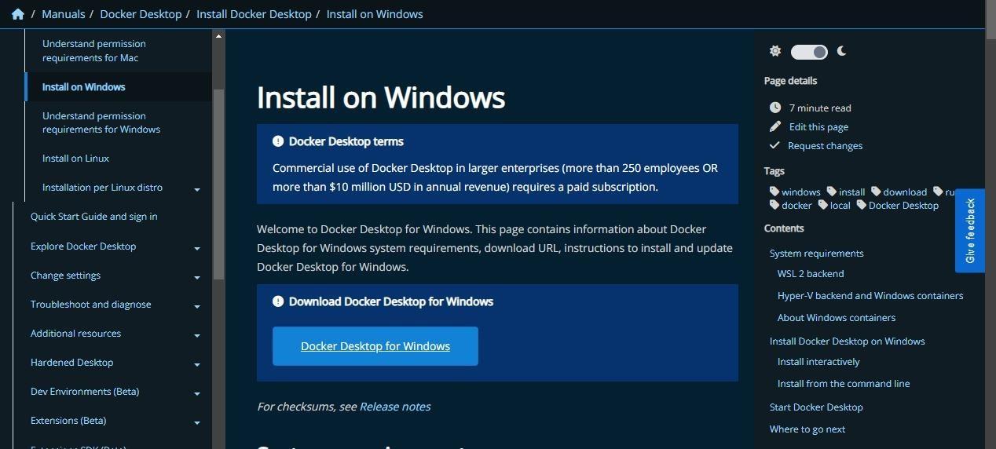

# Step 2:

Click that button (Docker Desktop for Windows) and download will start and it takes few minutes to complete.

# Step 3:

Go to downloads in browser (or) type **ctrl + J**, it will navigate to download page and double-click the particular docker file.

# Step 4:

Now Installation is complete. This icon was added in your desktop. Double-click the icon tostart the docker app, you can register and login that app to access those credentials.

# Step 5:

Docker will start correctly, the left bottom side was shown in green color, docker will show the status of docker app working successfully.

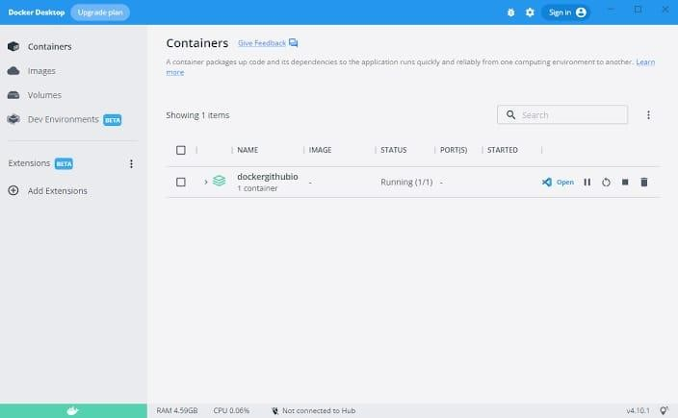

# Step 6:

Finally, the docker is installed successfully.